**# User guideline for “Food Donation Application”**

**1. Extract the zip file.**

**2. Make sure you have to read the Requirements catalog install java on your system.**

### Java

**You can download**

<https://www.java.com/download/ie_manual.jsp>

**Step 1)** Go to<https://www.java.com/download/ie_manual.jsp>. Click on JDK Download for Java download JDK 8.

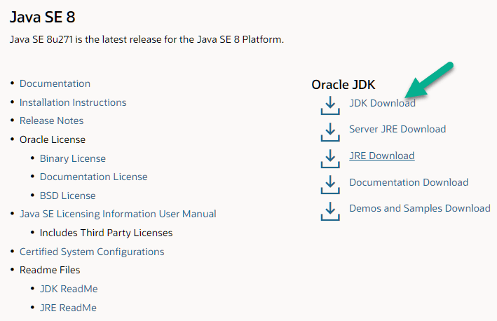

**Step 2)** Next,

1. Accept License Agreement
2. Download Java 8 JDK for your version 32 bit or JDK download 64 bit.

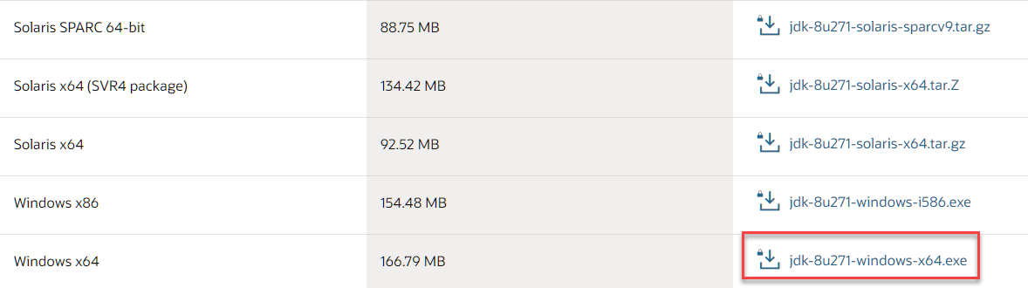

**Step 3)** When you click on the Installation link the popup will be open. Click on I reviewed and accept the Oracle Technology Network License Agreement for Oracle Java SE development kit and you will be redirected to the login page. If you don’t have an oracle account you can easily sign up by adding basics details of yours.

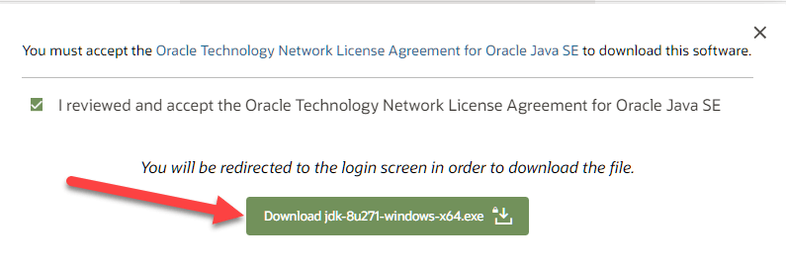

**NOTE:** You will be required to create an Oracle Account to start Java 8 download of the file.

**Step 4)** Once the Java JDK 8 download is complete, run the exe for install JDK. Click Next

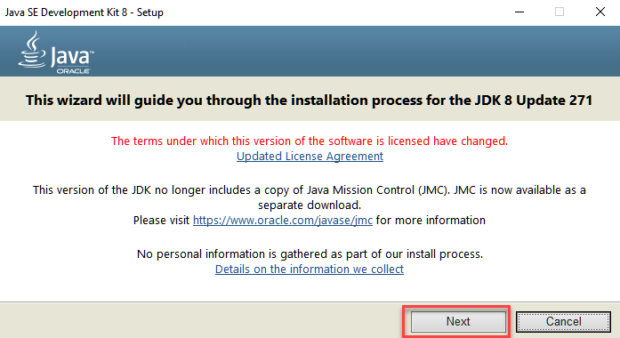

**Step 5)** Select the PATH to install Java in Windows… You can leave it Default. Click next.

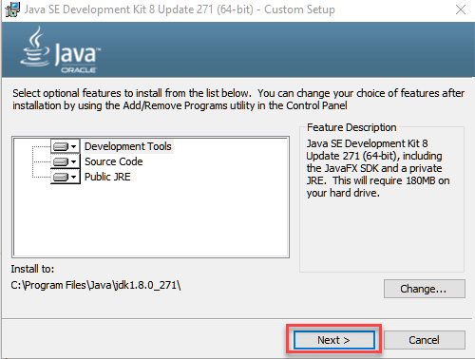

**NOTE:** Follow the onscreen instructions in succeeding steps to install Java 8 on Windows 10.

**Step 6)** Once you install Java in windows, click Close

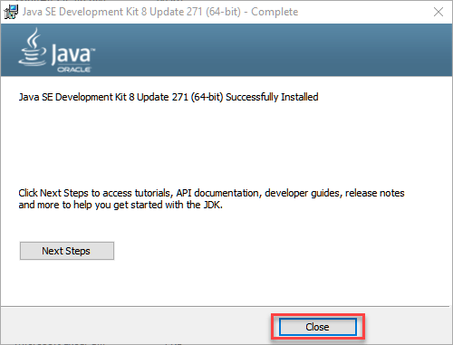

## How to set Environment Variables in Java: Path and Classpath

The PATH variable gives the location of executables like javac, java etc. It is possible to run a program without specifying the PATH but you will need to give full path of executable like **C:\Program Files\Java\jdk1.8.0_271\bin\javac A.java** instead of simple **javac A.java**

The CLASSPATH variable gives location of the Library Files.

Let’s look into the steps to set the PATH and CLASSPATH

**Step 1)** Right Click on the My Computer and Select the properties

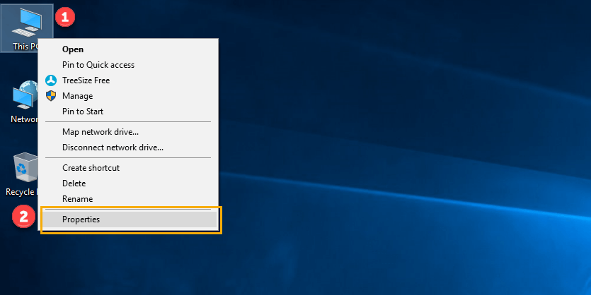

**Step 2)** Click on advanced system settings

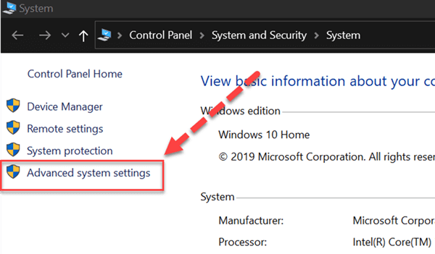

**Step 3)** Click on Environment Variables to set Java runtime environment

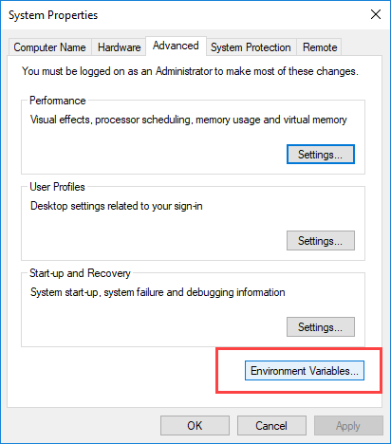

**Step 4)** Click on new Button of User variables

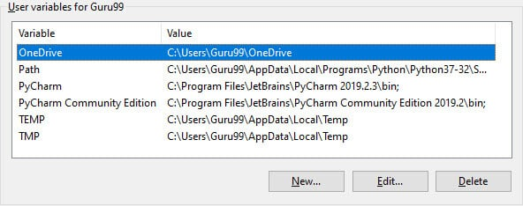

**Step 5)** Type PATH in the Variable name.

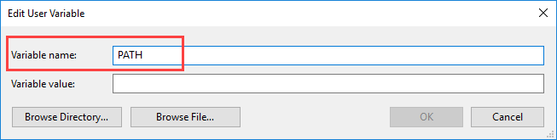

**Step 6)** Copy the path of bin folder which is installed in JDK folder.

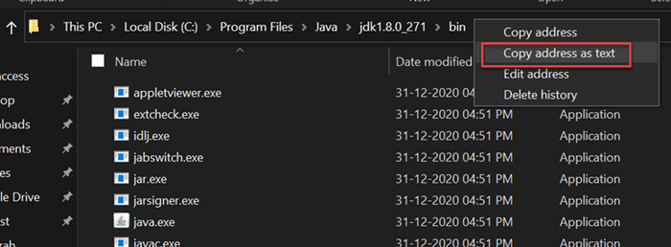

**Step 7)** Paste Path of bin folder in Variable value. Click on OK Button.

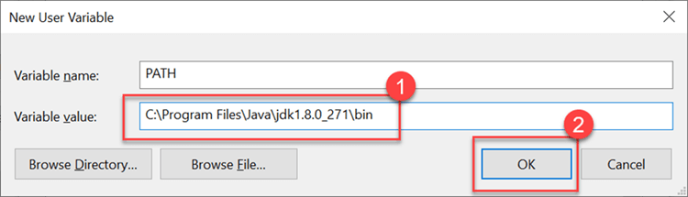

**Note:** In case you already have a PATH variable created in your PC, edit the PATH variable to

PATH = <JDK installation directory>\bin;%PATH%;

Here, %PATH% appends the existing path variable to our new value

**Step 8)**You can follow a similar process to set CLASSPATH.

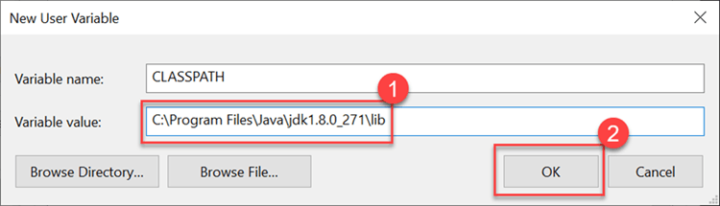

**Note:** In case you java installation does not work after installation, change classpath to

CLASSPATH = <JDK installation directory>\lib\tools.jar;

**Step 9)** Click on OK button

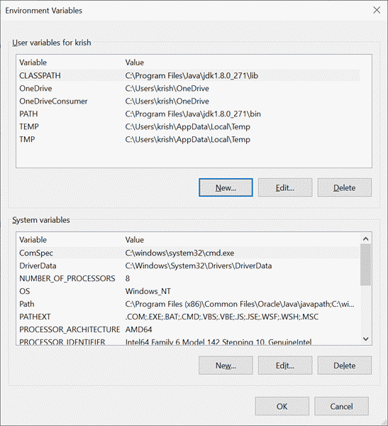

**Step 10)** Go to command prompt and type javac commands.

If you see a screen like below, Java is installed.

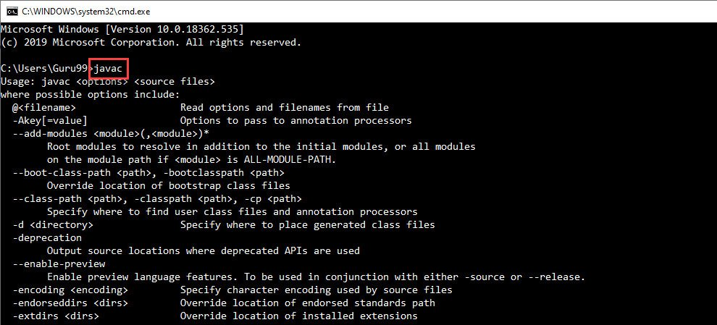

### 3 And with all installed download Android Studio & Android SDK

### <https://developer.android.com/studio>

### ****Installation Guide****

**Step 1:**Head over to [**this link**](https://developer.android.com/studio/#downloads) to get the Android Studio executable or zip file.

**Step 2:**Click on the **Download Android Studio** Button.

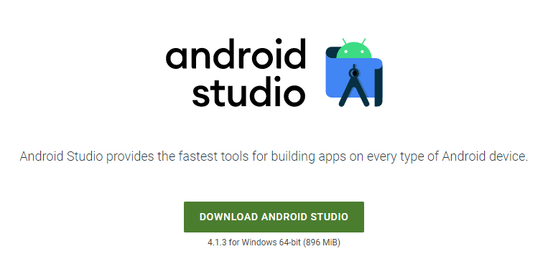

Click on the “I have read and agree with the above terms and conditions” checkbox followed by the download button.

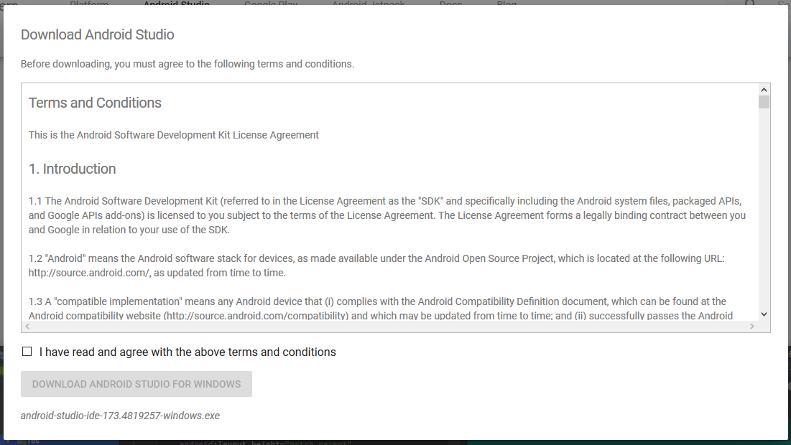

Click on the Save file button in the appeared prompt box and the file will start downloading.

**Step 3:**After the downloading has finished, open the file from downloads and run it. It will prompt the following dialog box.

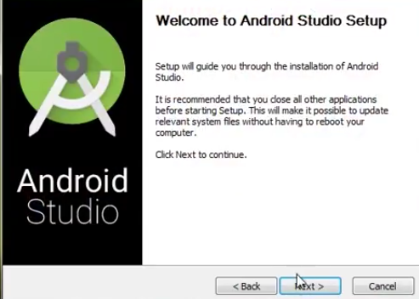

Click on next. In the next prompt, it’ll ask for a path for installation. Choose a path and hit next.

**Step 4:**It will start the installation, and once it is completed, it will be like the image shown below.

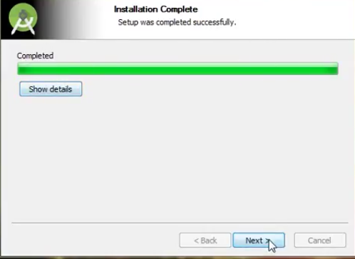

Click on next.

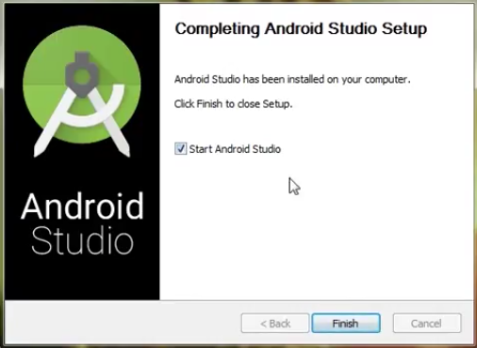

**Step 5:**Once “**Finish**” is clicked, it will ask whether the previous settings need to be imported [if the android studio had been installed earlier], or not. It is better to choose the ‘Don’t import Settings option’.

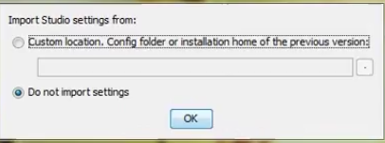

Click the **OK**button.

**Step 6:**This will start the Android Studio.

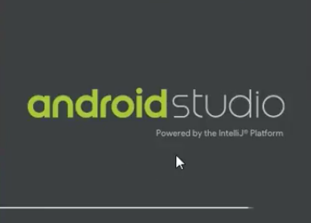

Meanwhile, it will be finding the available SDK components.

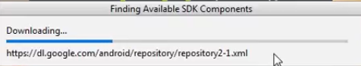

**Step 7:**After it has found the SDK components, it will redirect to the Welcome dialog box.

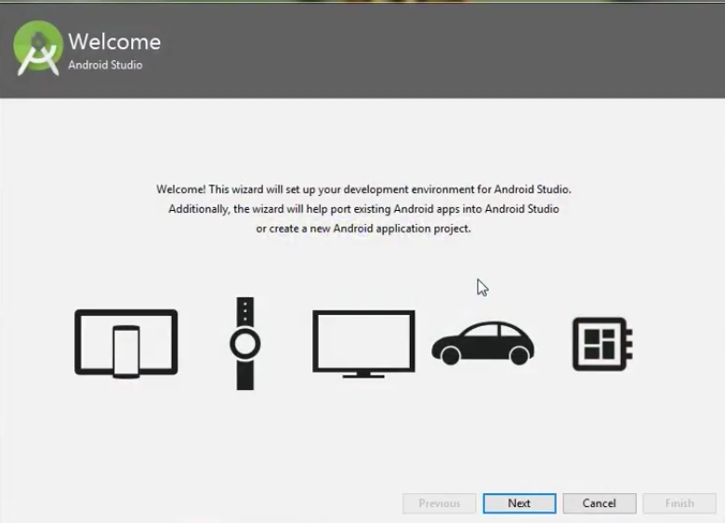

Click on **Next**.

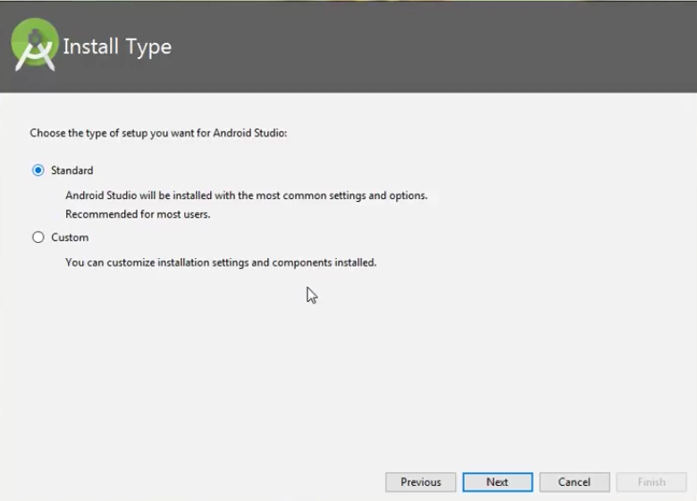

Choose Standard and click on Next. Now choose the theme, whether the **Light**theme or the **Dark**one. The light one is called the **IntelliJ**theme whereas the dark theme is called **Darcula**. Choose as required.

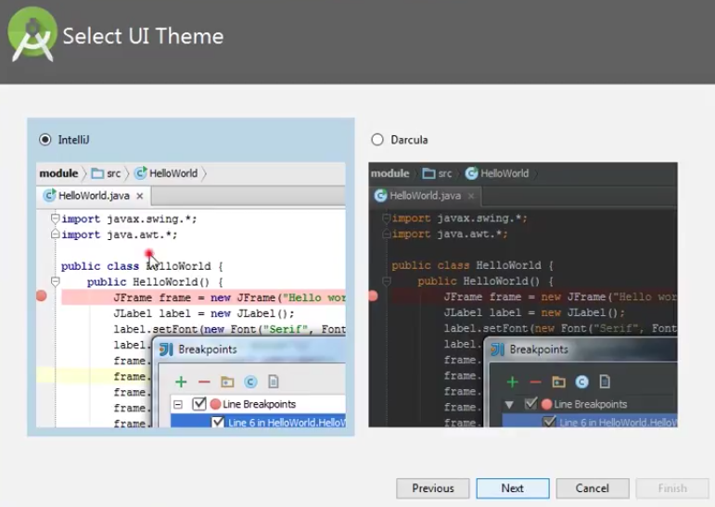

Click on the **Next**button.

**Step 8:**Now it is time to download the SDK components.

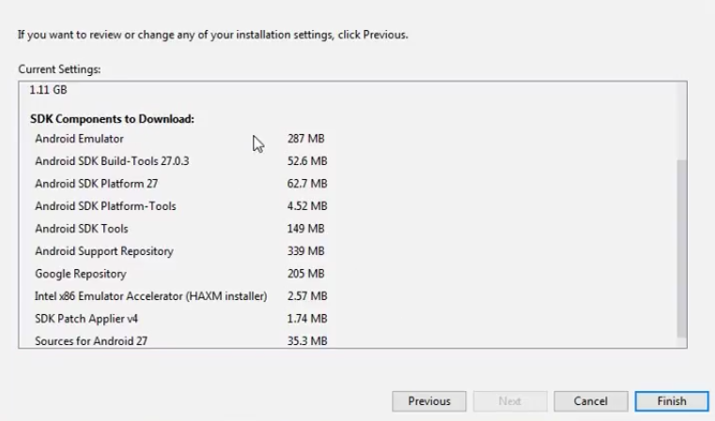

Click on Finish. Components begin to download let it complete.

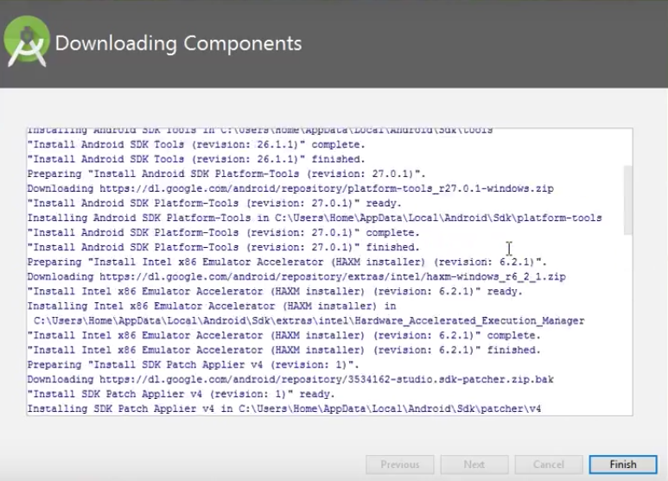

The Android Studio has been successfully configured. Now it’s time to launch and build apps. Click on the Finish button to launch it.

**Step 9:**Click on **Start a new Android Studio project** to build a new app.

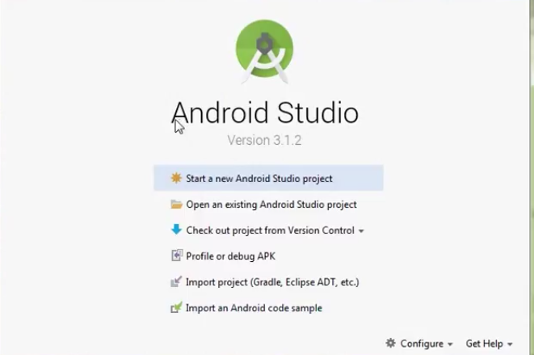

**And select existing android Studio Project and add select the previously extracted folder and create an emulator using adv manager**

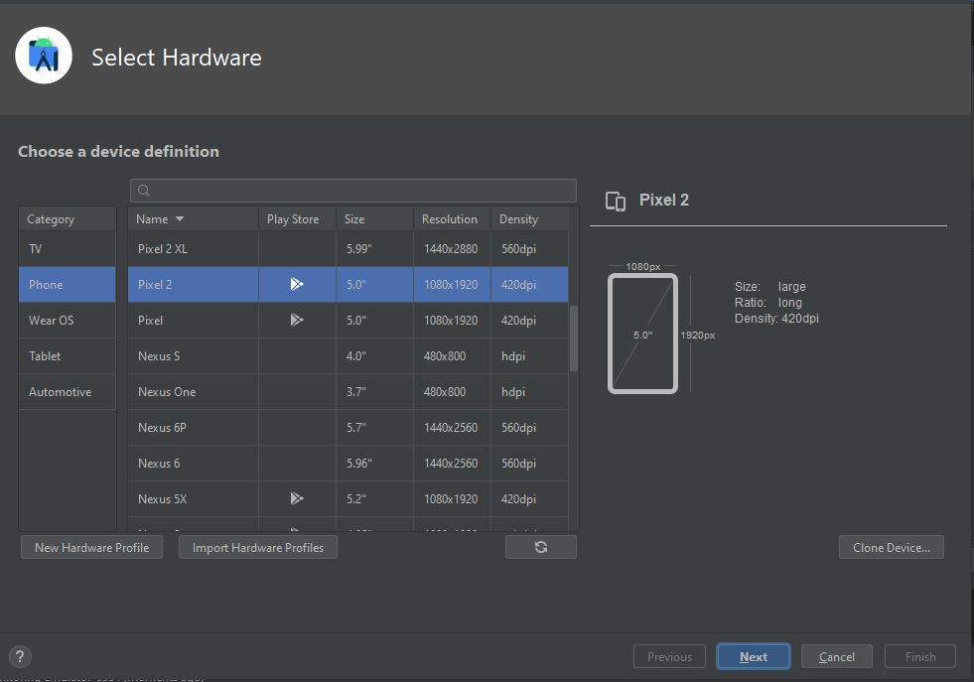

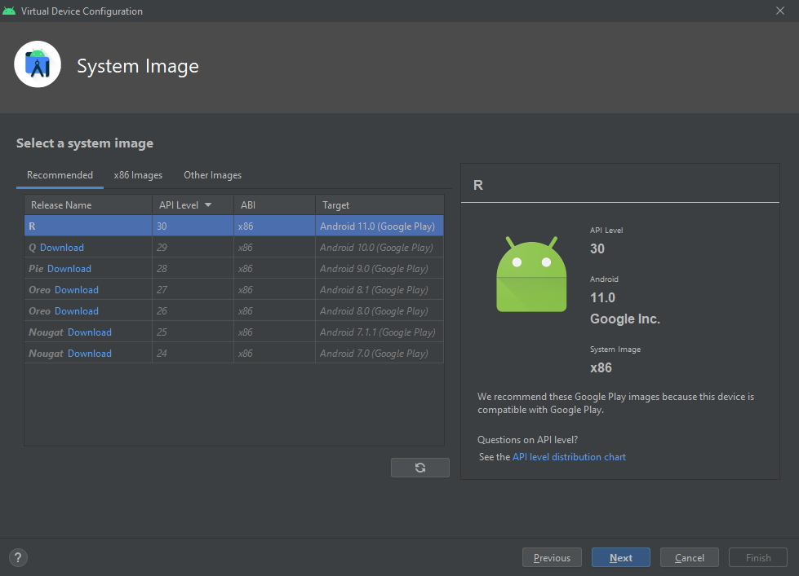

**Now select the android version**

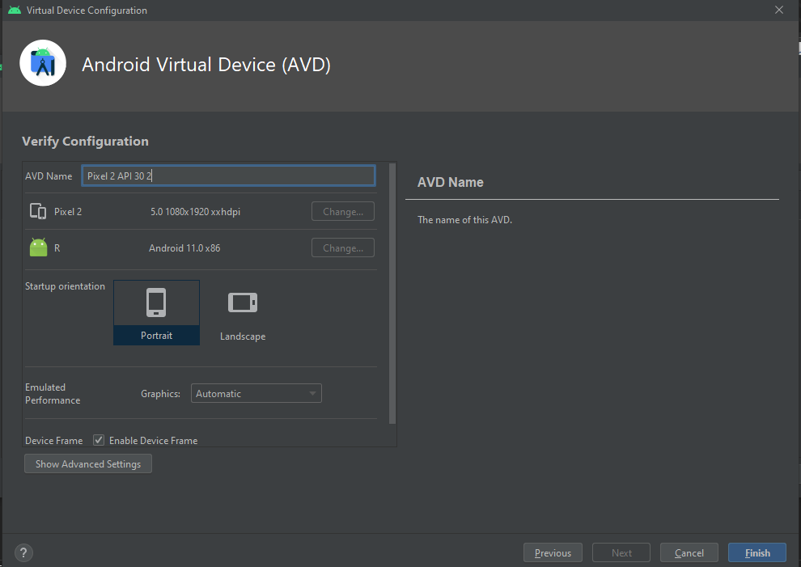

**Now click finish**

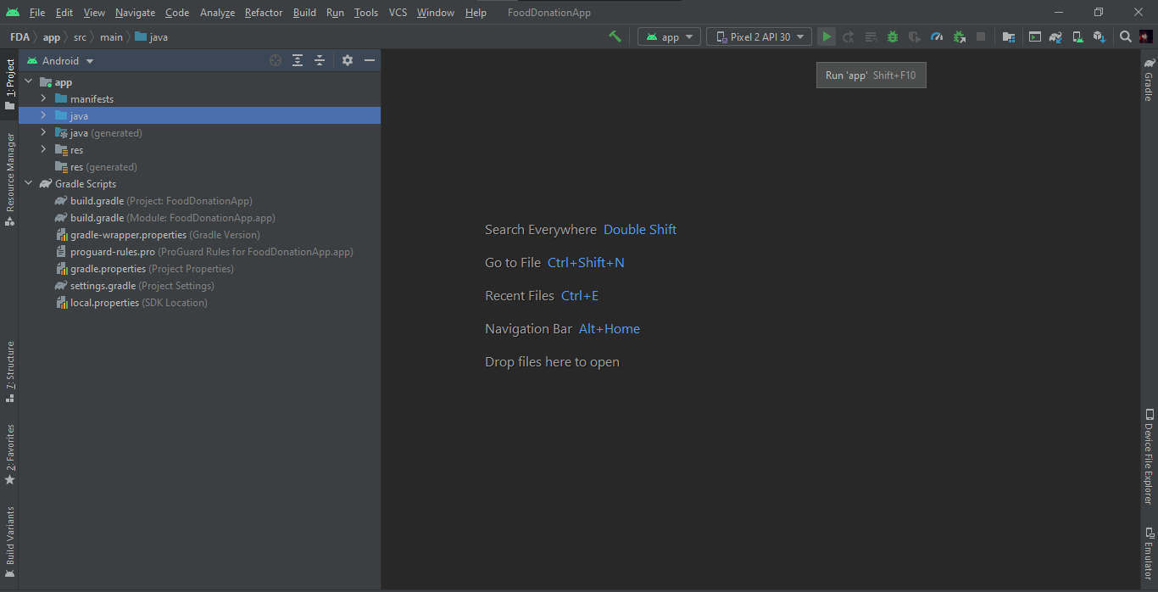

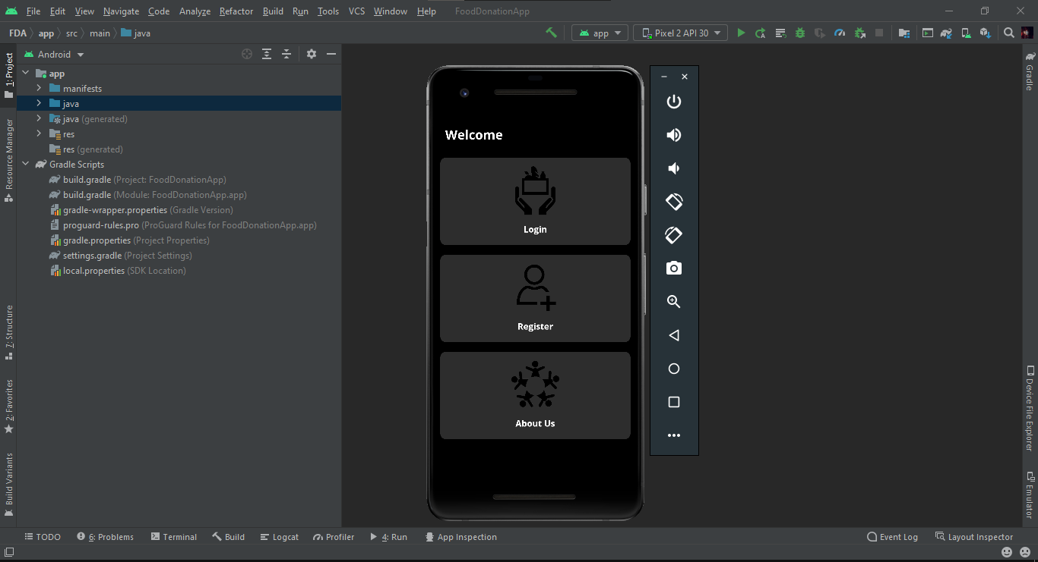

**AND YOU'RE GOOD TO GO!**